CLOUD FRONT AND ROOT 53 TASK
- Configure Vpc Peering In Cross Regions.
- Crete two vpc in two different region or zone
- Create peering connection
- Select the same account and different region
- Provide the acceptor vpc and requestor vpc
- The create the peering connection

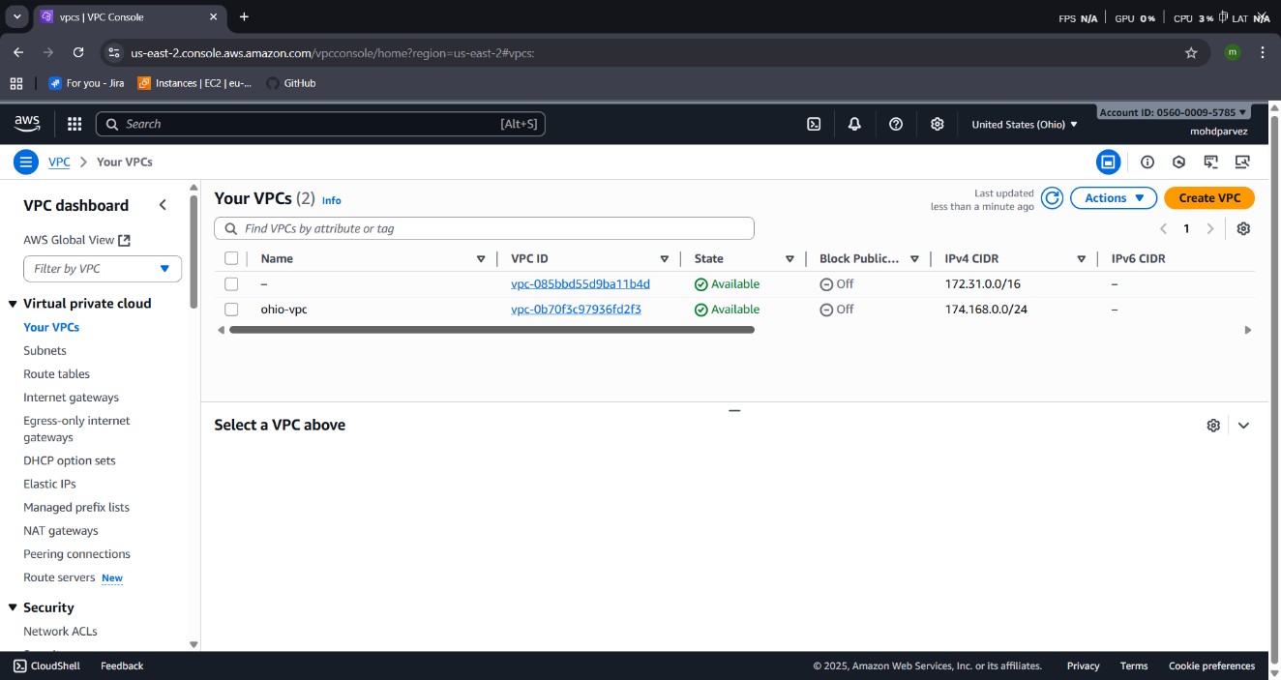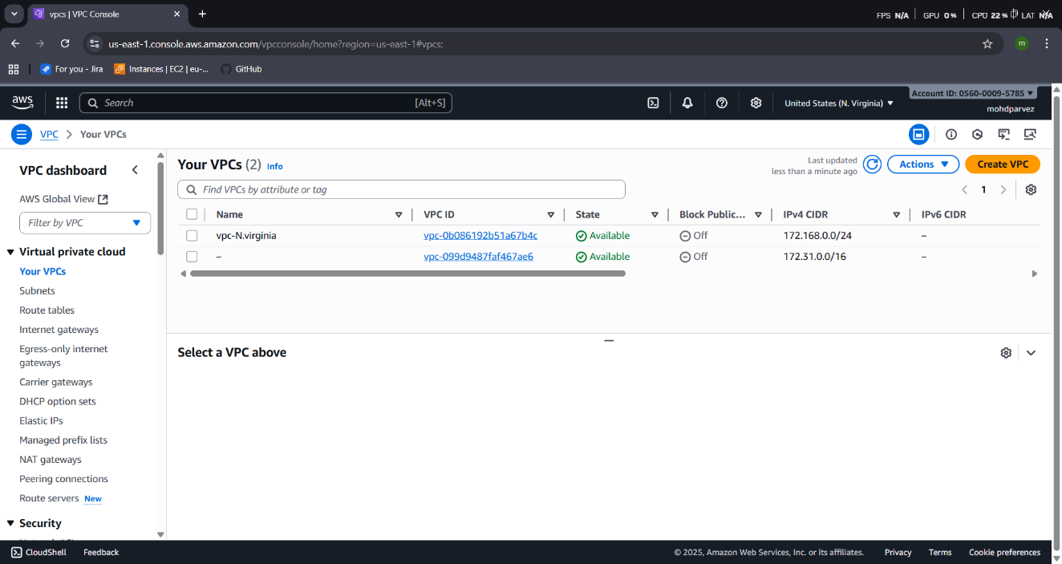
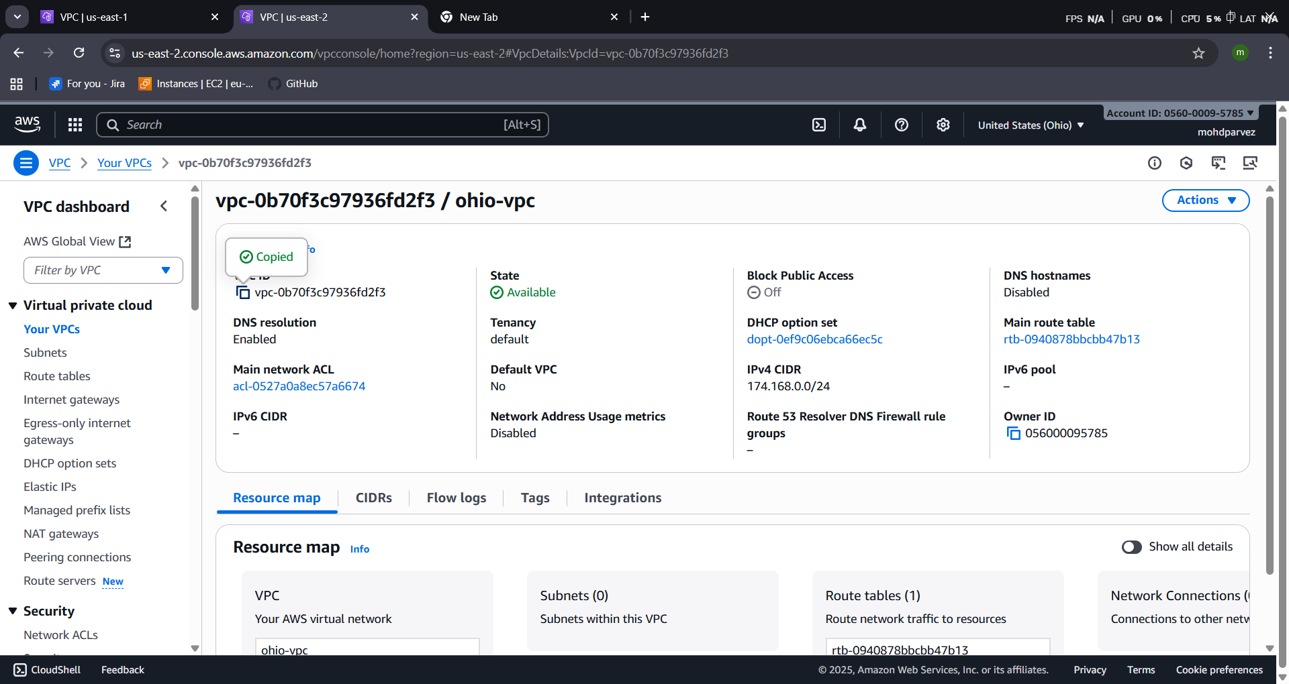
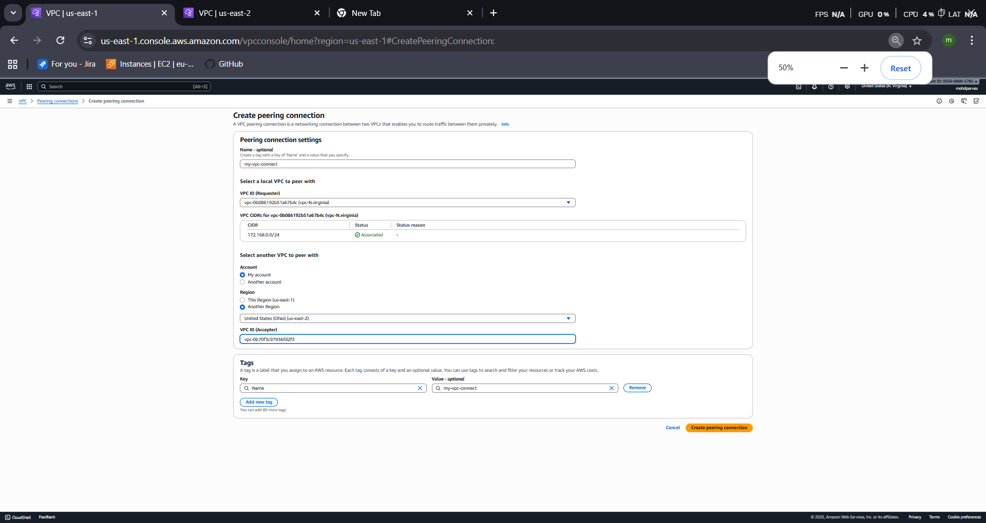
- The peering re quest will be sent to the vpc to other region
- Accept the request and the vpc peering connection will be established

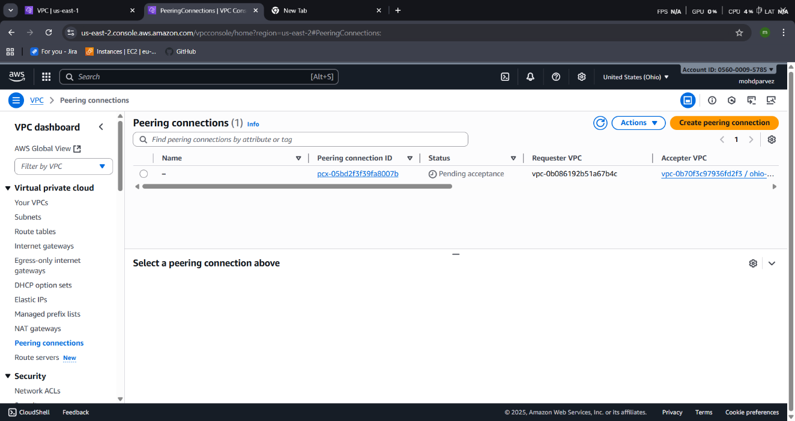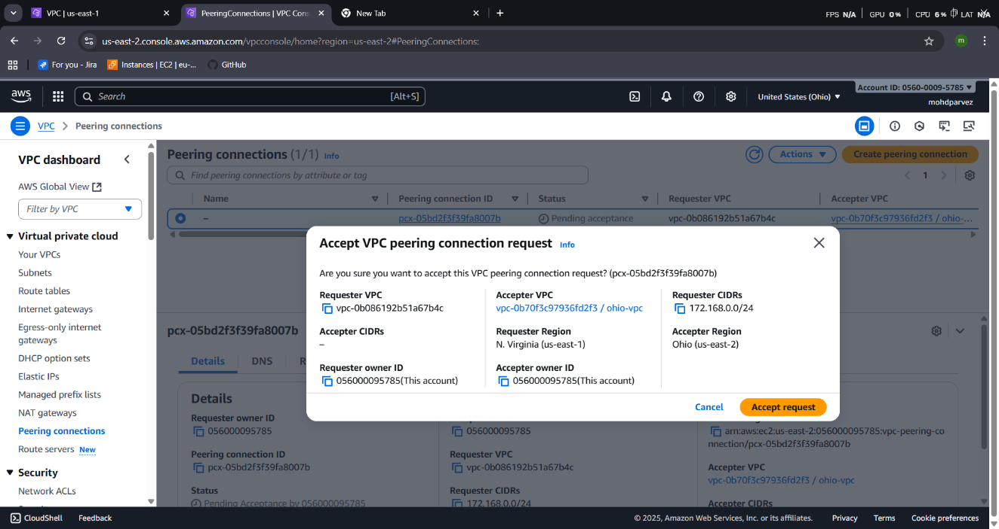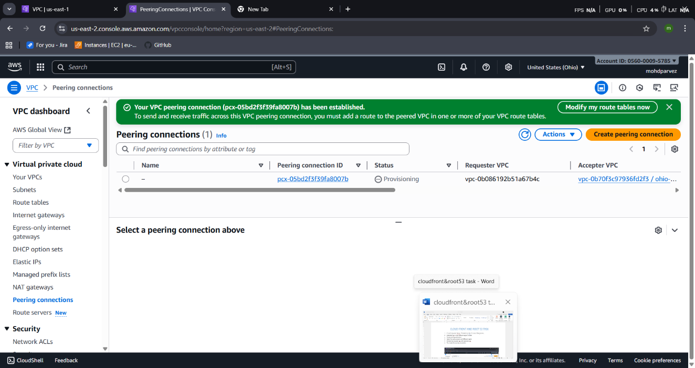

- PURCHASE ONE DOMAIN FROM GODADDY.
- Go to go daddy
- Search for domain find the domain with your estimated price
- Select the time period youwant it for
- Add cart -- checkout – payment
- Domain has been purchased
- You will get the confirmation mail after buiying
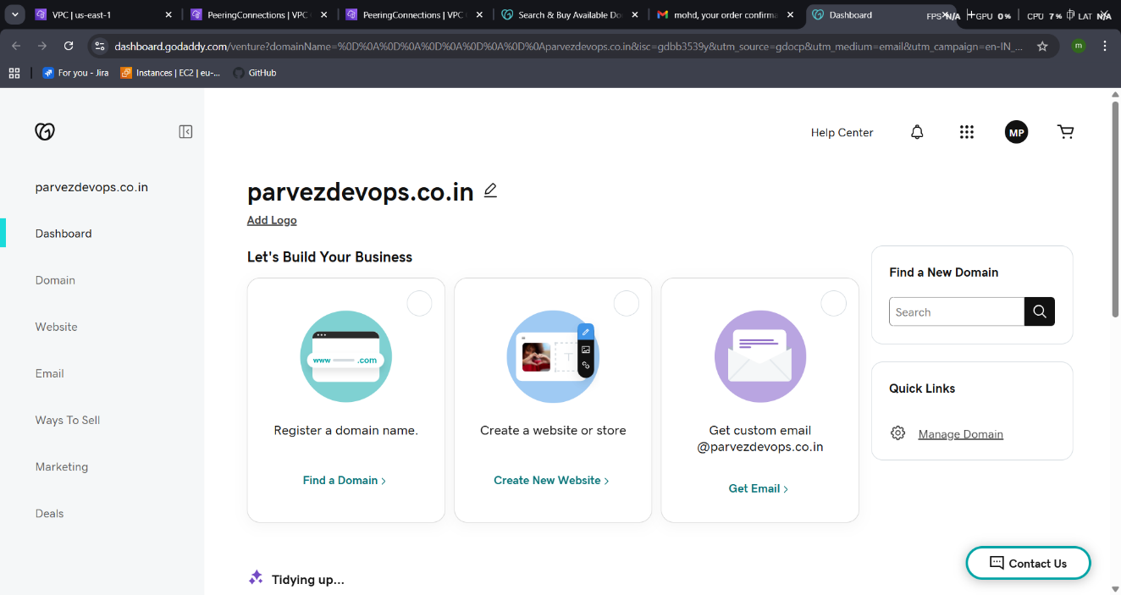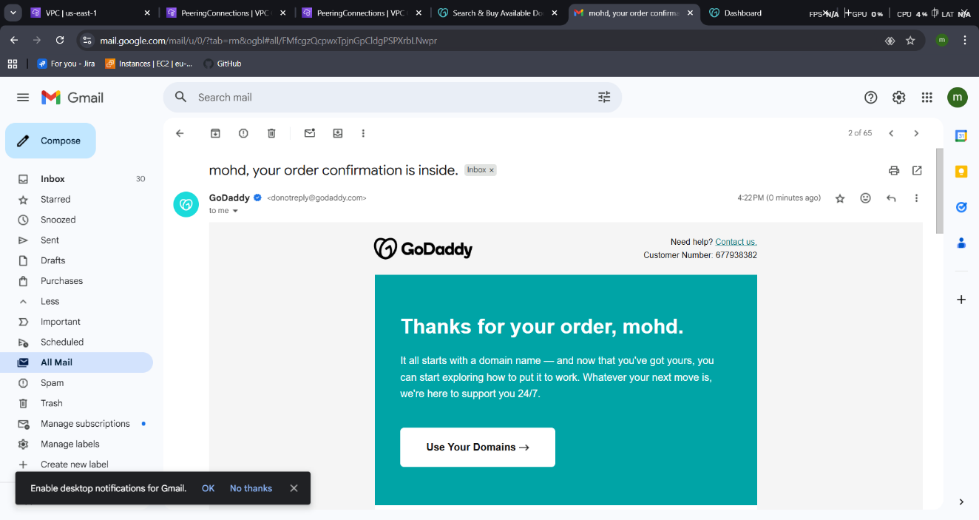

- DEPLOY STATIC WEBSITE IN S3.
- Go to the s3 bucket
- Properties – enable statis website hosting.
- Give the files names index.html & error.html
- The save the website hosting will be established
- Upload the index.html & error.html files to the bucket make it public acess

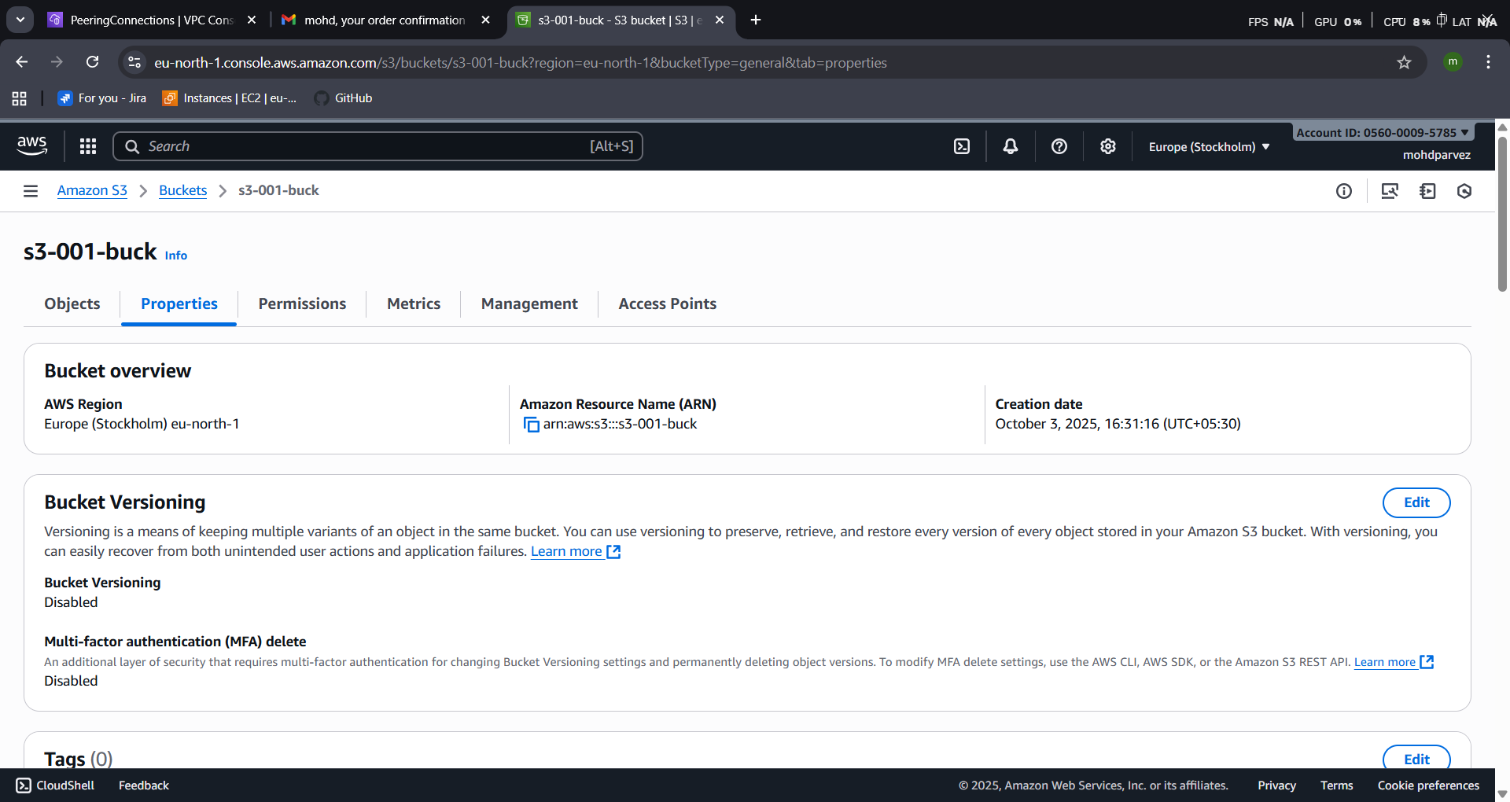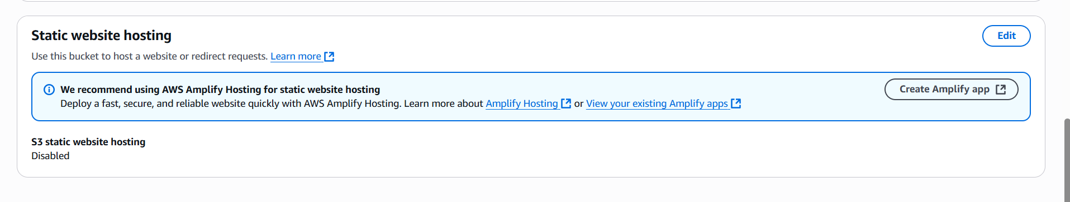
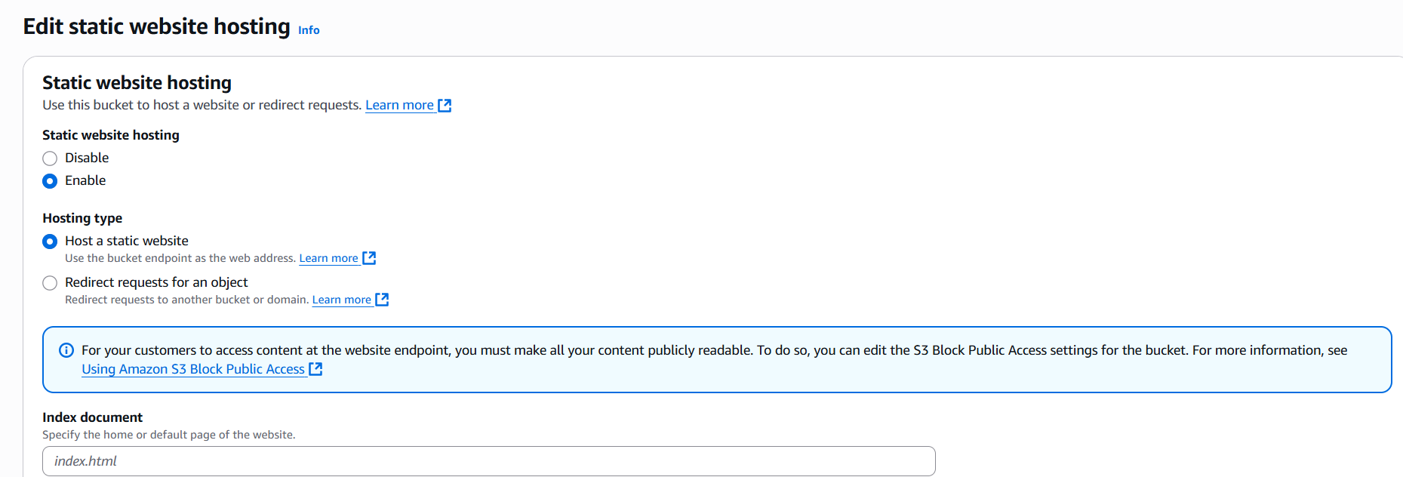
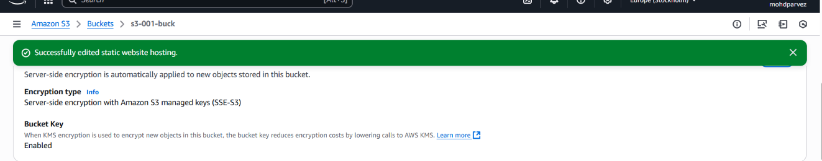

- Copy the link generated and paste it in the browser to check

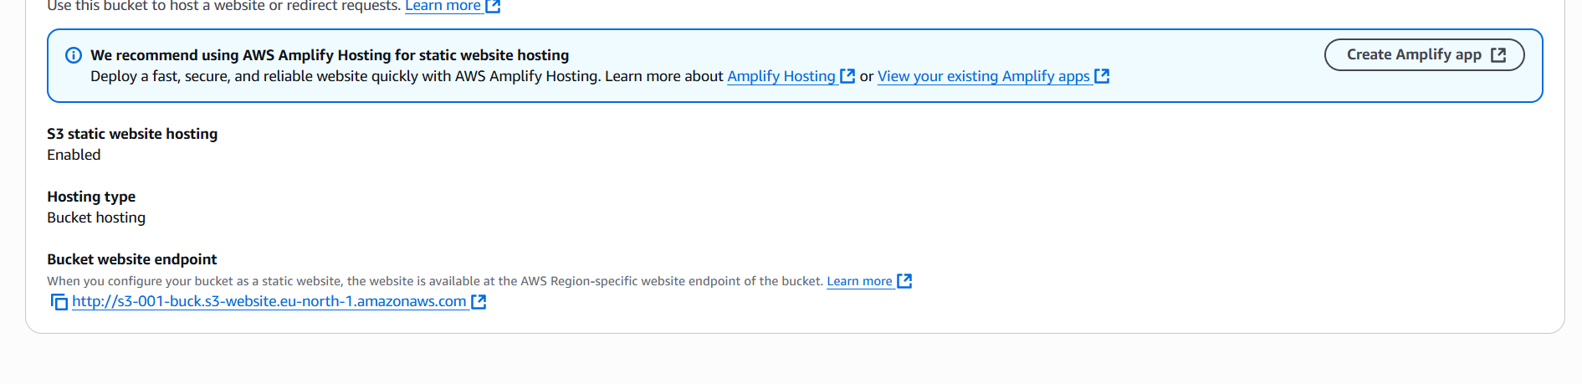
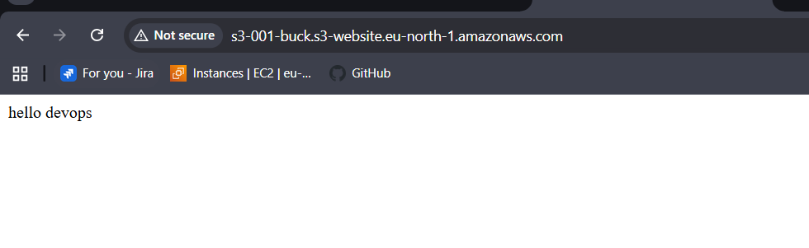
- Create a CDN and attach one SSL certificate.
- Go to the certificate in aws console
- Provide the domain name that you purchased : parvezdevops.co.in
- Then click on request
- Wait for its validation it might take some time .
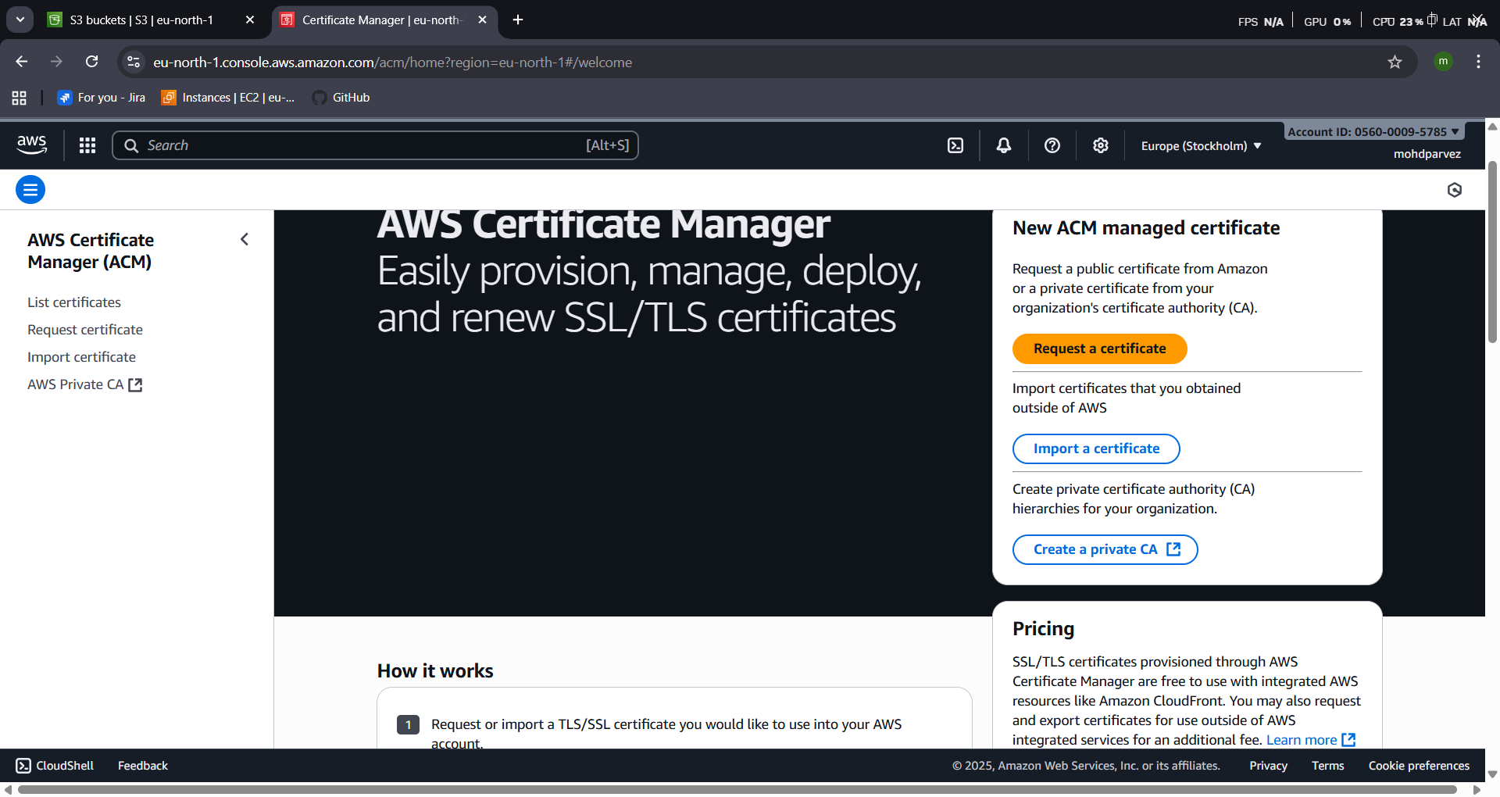
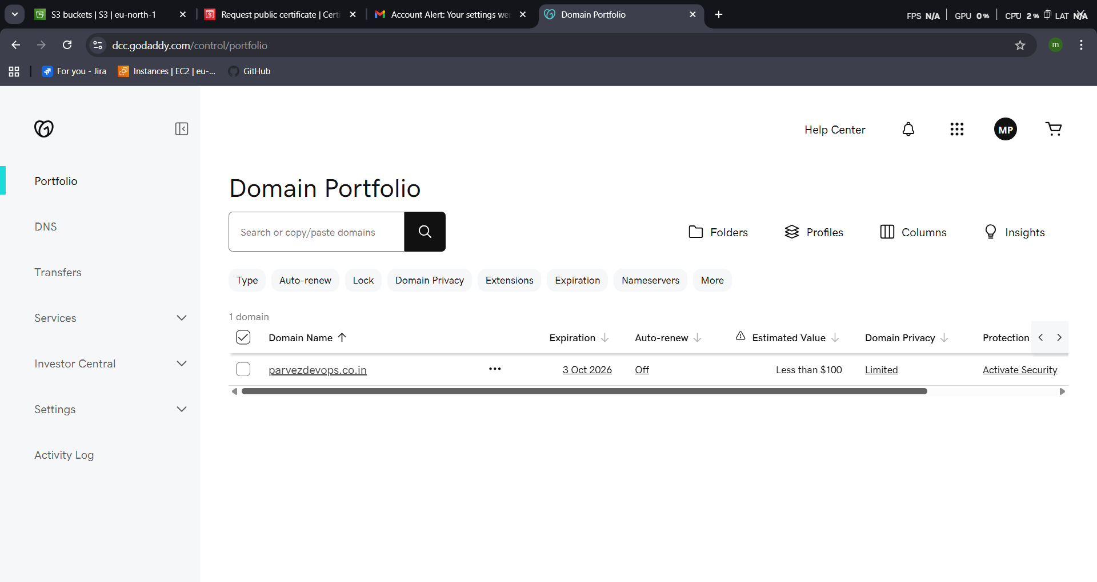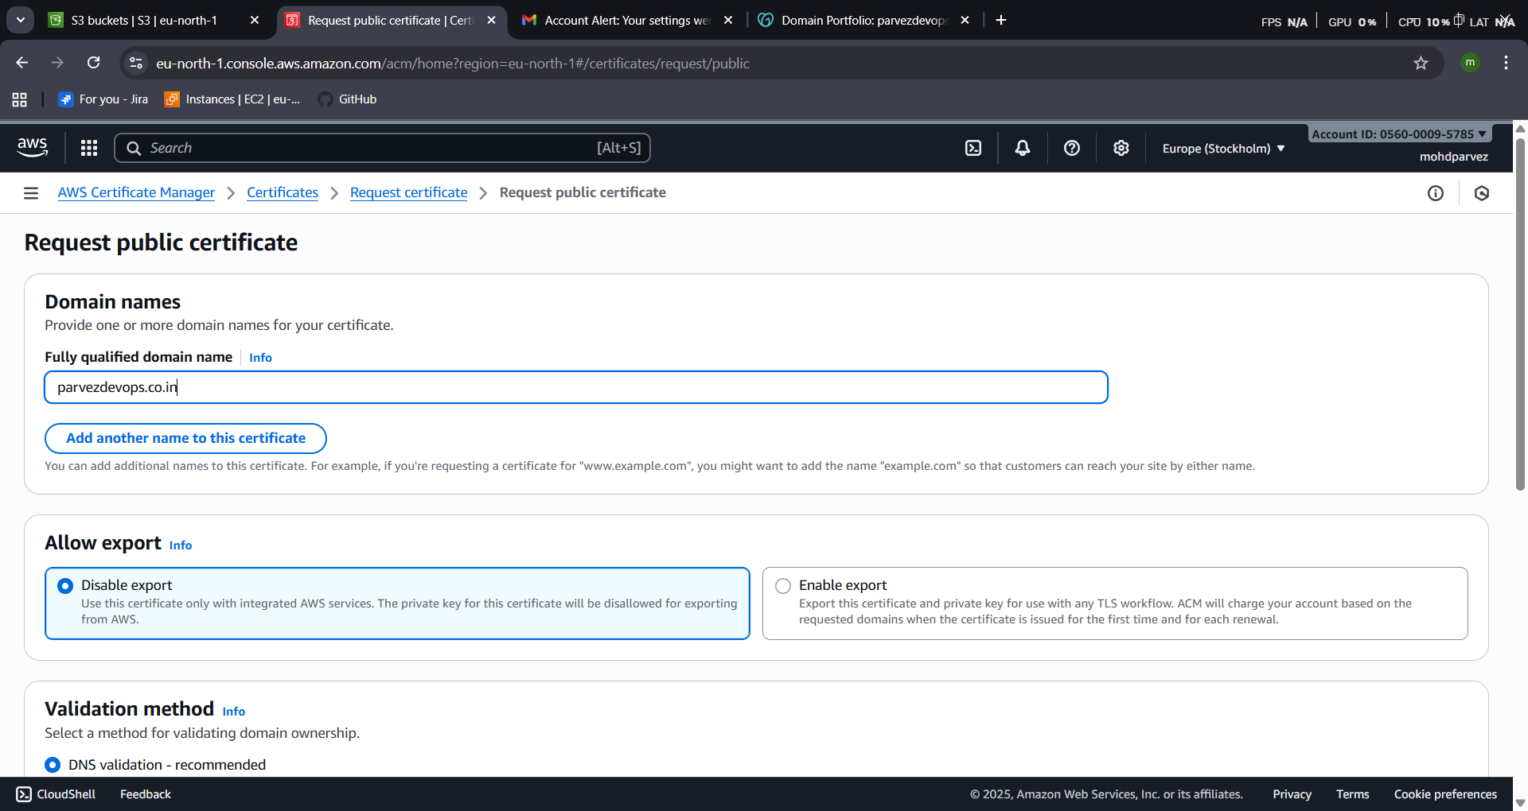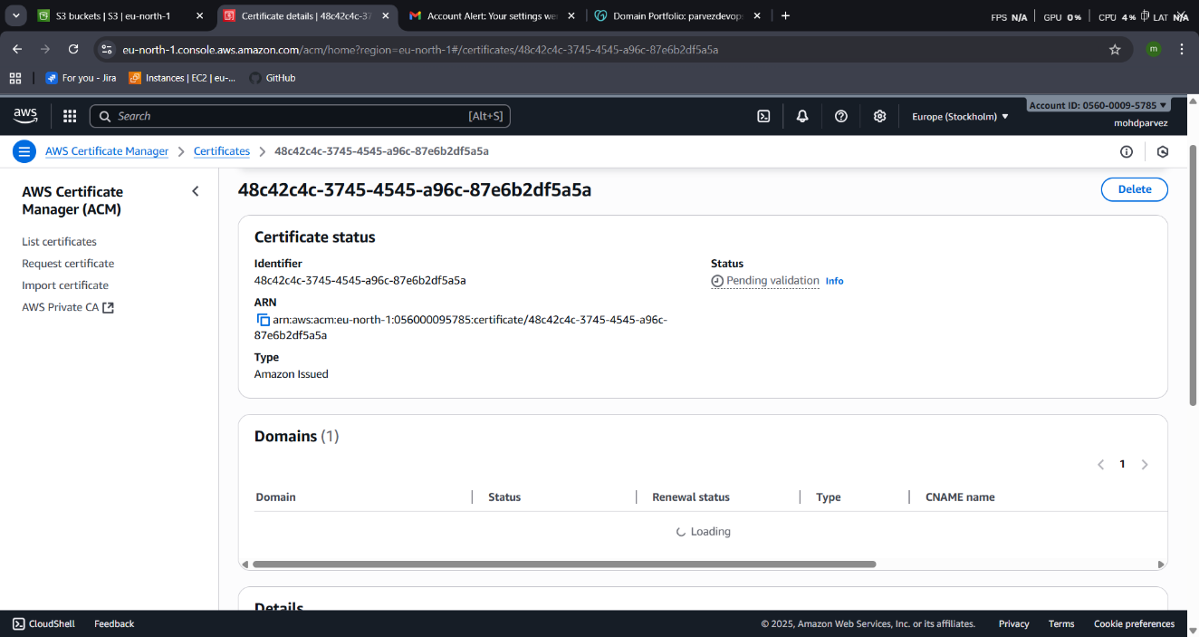

- Create s3 bucket with the same domainname
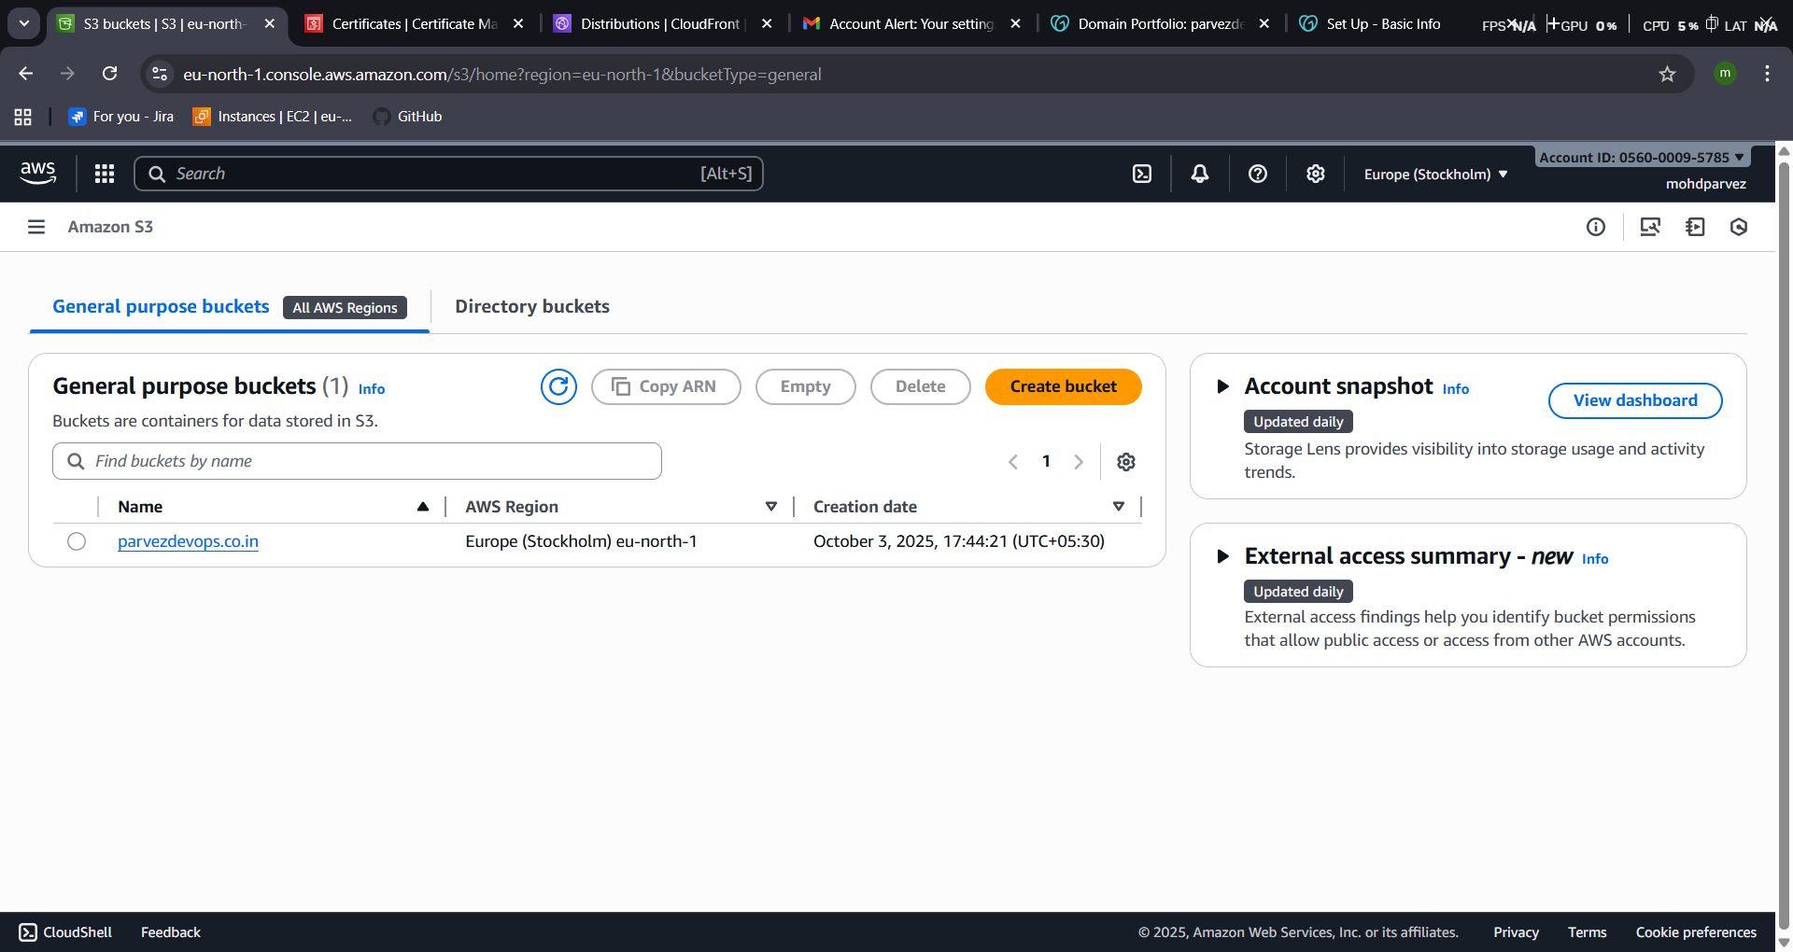
- now go to cloud front and create distribution with the https protocol
- create distribution – check domain
- slelect the protocol -redirect http -https
- webacess firewall : disabled
- alternate domain name : provide the domain name
- ads ssl
- create distribution
- deploy :
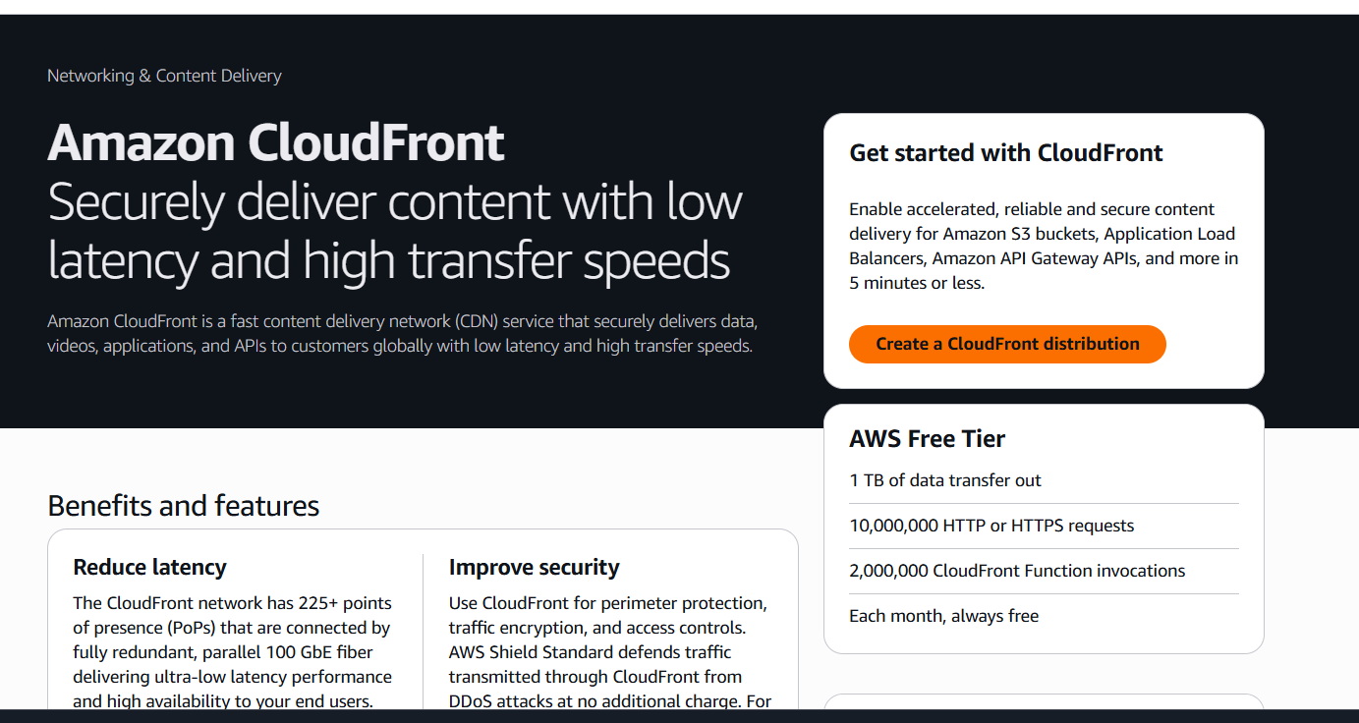
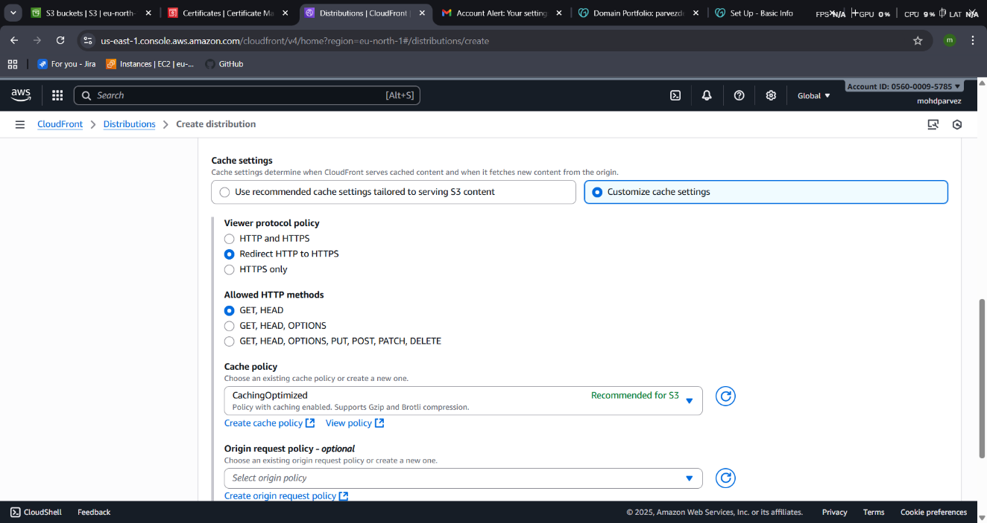
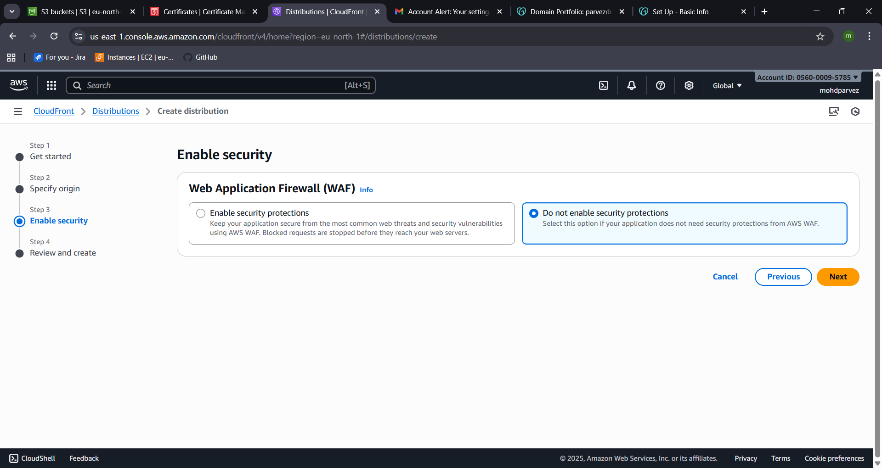
- go to cloud distribution created
- origin – give the link of the s3 static web host
- save
- copy the link of the cloud front distribution and check in the browser

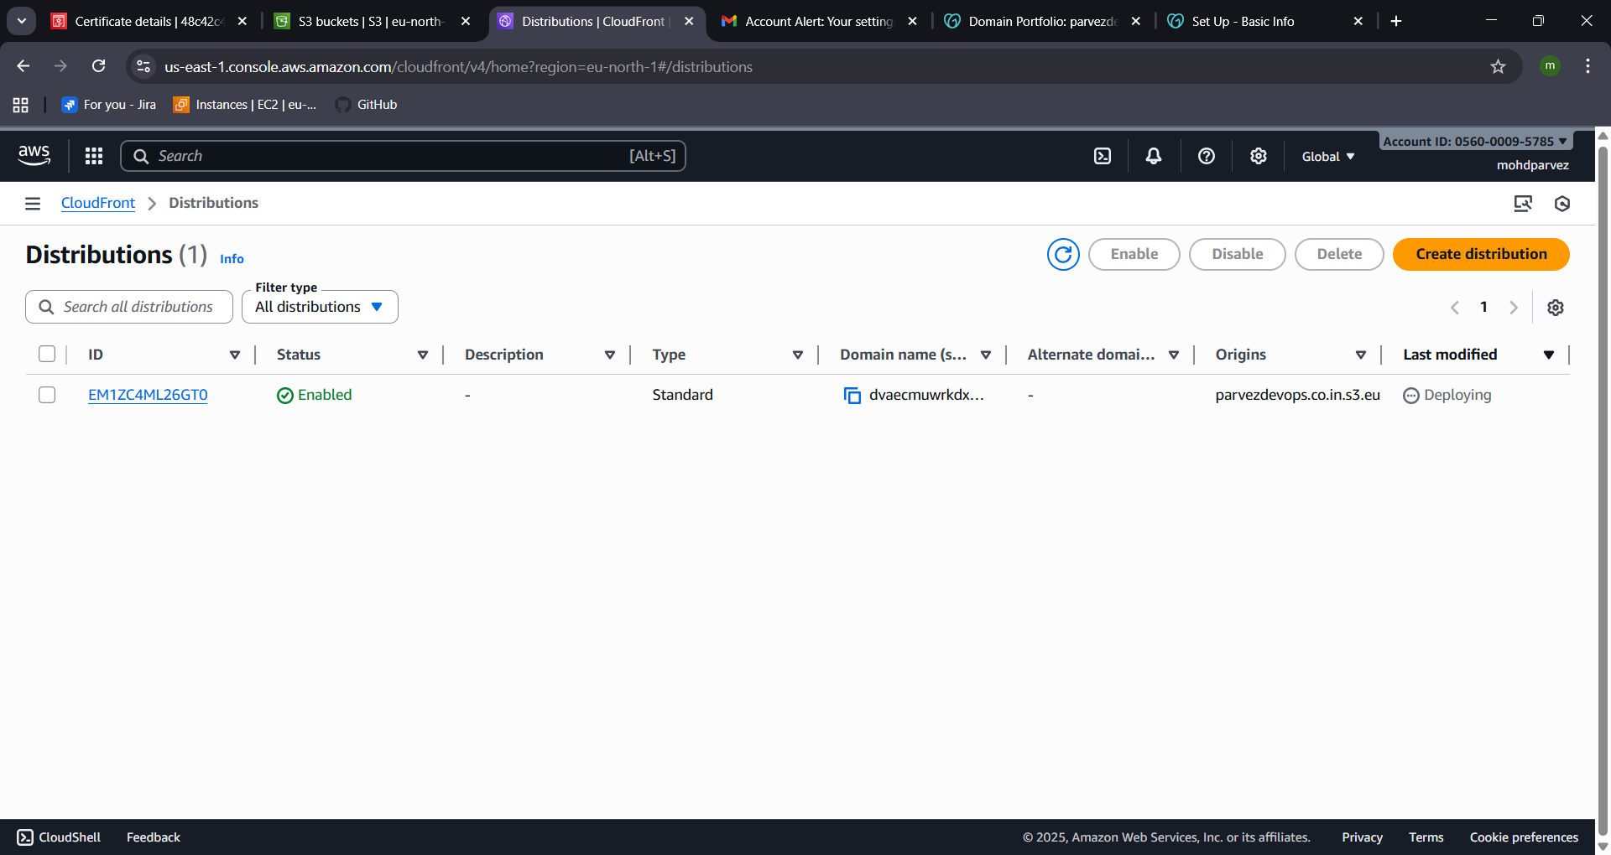
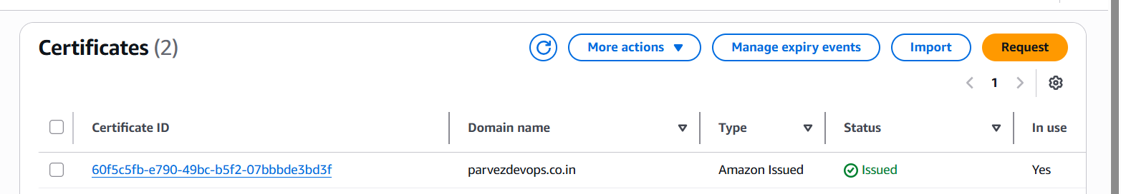
- The certificate is issued successfully
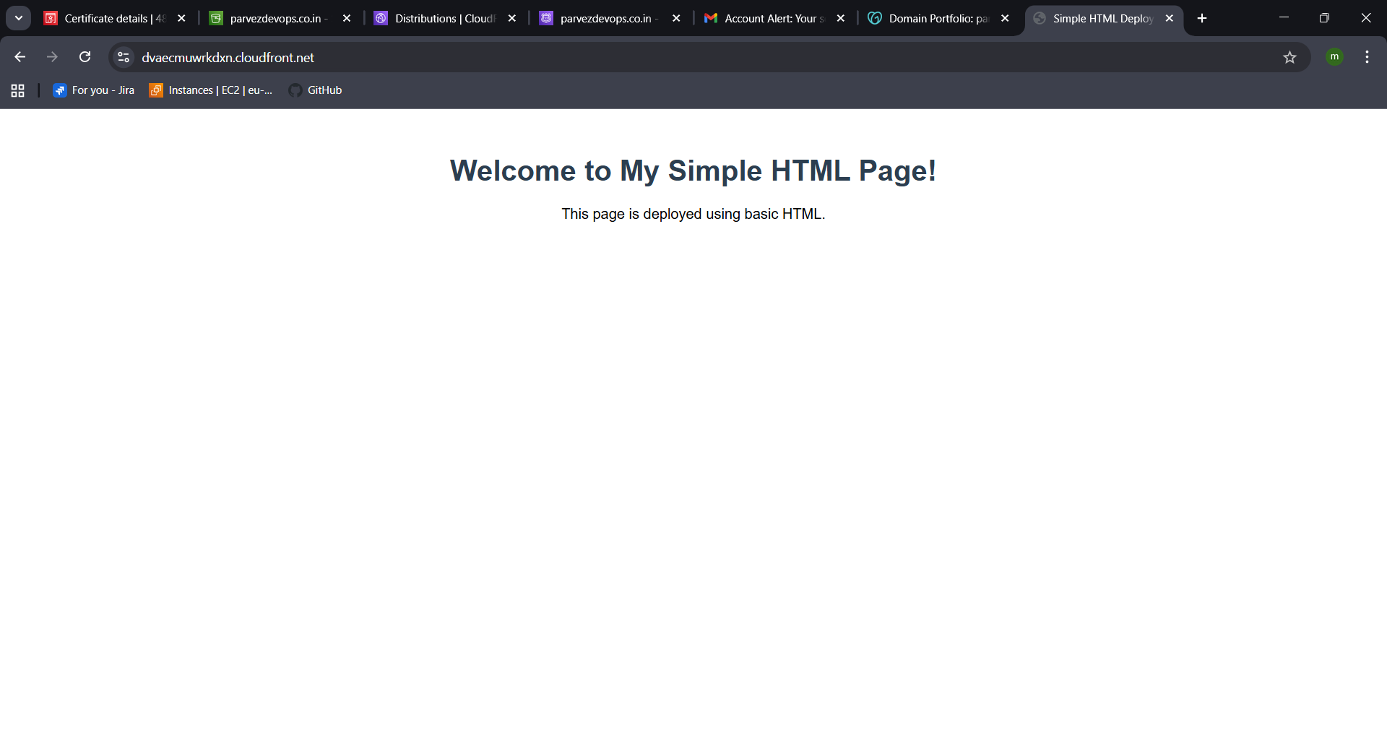

- Create a Route 53 hosted zone and map the domain with the CDN.
- Go to root 53 in aws console
- Create records to the
- The four websites will be generated go to go daddy.com
- Your domain – name servers -copy the four dns names and add it in the server names
- In the go daddy.
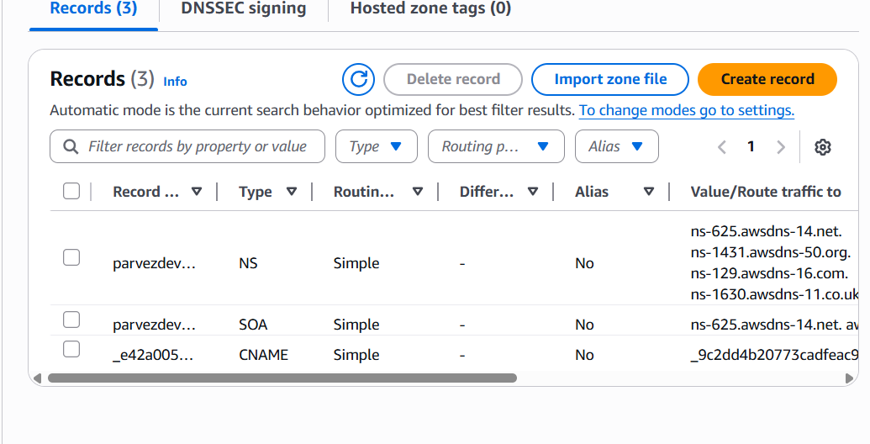
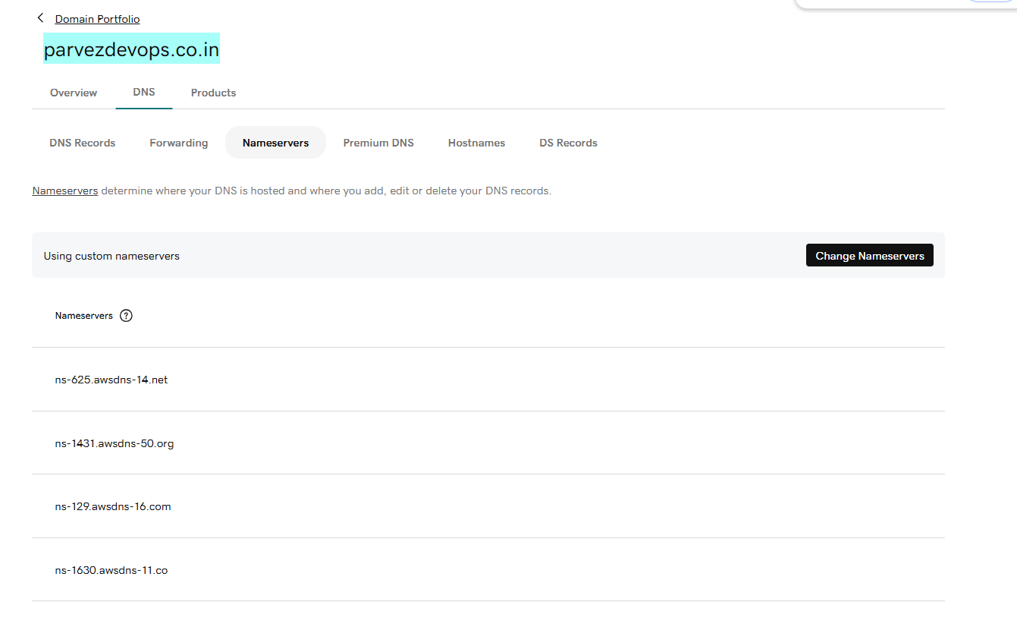

- Update the index.html in the S3 bucket and ensure the updated file is accessible using the domain name.
- Go to the cloud front distribution.
- And copy the distribution domain name.
- And paste it in the browser.
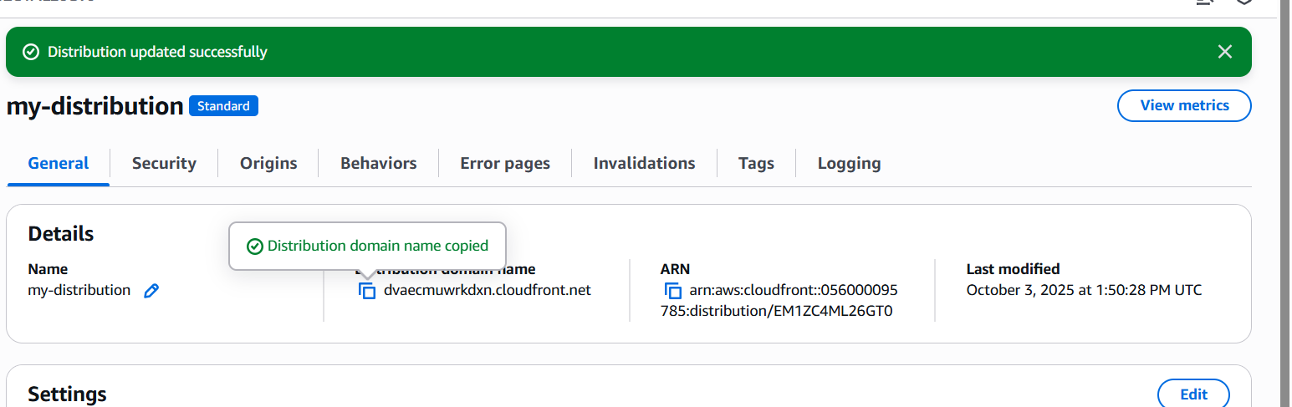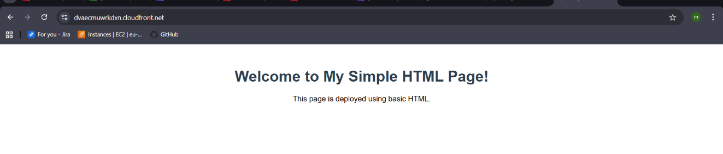
- Share the domain name in Slack to test the connectivity.

Parvezdevops.co.in
